Front-end and API exercises
- Create an F1 frontend similar, not necessarily the same, as that shown below. The F1 leaderboard link at the bottom takes you to another page where your table lives (see page 2). Just use a static table. i.e. just type the values into the table.
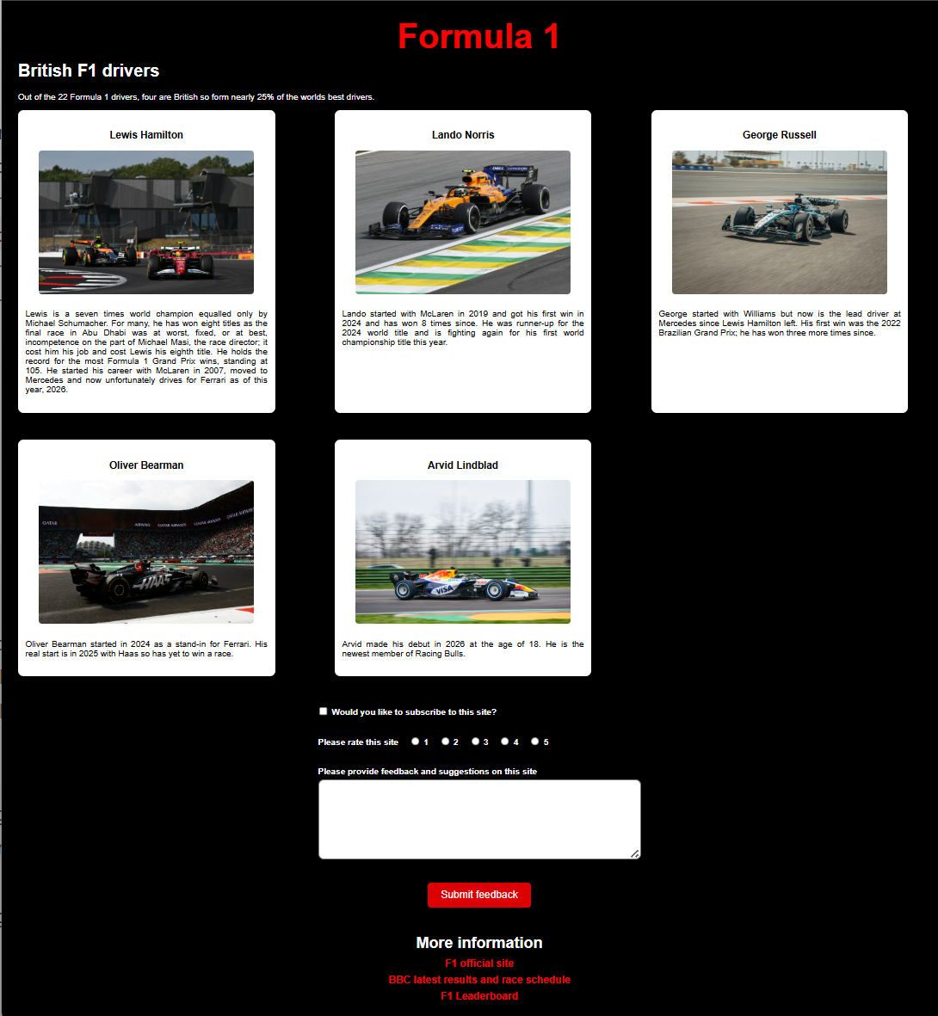
It doesn’t need to be perfect. It doesn’t need to scale to all platform sizes. You can use your imagination.
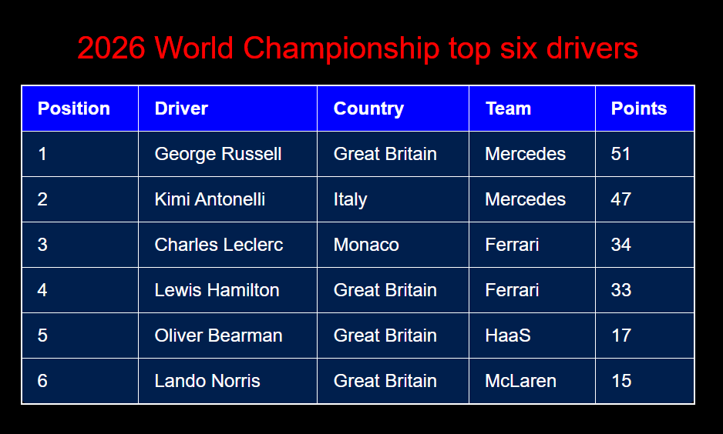
Leaderboard web page
- Using the price list API you created last week, create a very simple front-end to fetch data and populate a table in a similar way to the demo showing student results. You can do this in one of two ways:
Run the back-end in one VScode process then in a second process run your frontend – that was how the demo worked. Note: as this is a cross-origin request, you will need to add a package and a couple of lines of code to your backend. Use: npm i cors to install the package. Also add the following code into your app.js so you can use the package:
const cors = require('cors')
app.use(cors())
This will stop the CORS errors.
Alternatively, and a better option, copy your frontend files to a directory in your backend project and add the static middleware to the backend. i.e., add a directory called public or similar, copy your frontend html, css and js into it, then add the following to your backend code:
app.use(express.static('./public'))
Start your backend server in vscode
If your frontend html is called f1.html then access your backend from the browser using
http://localhost:3000/f1.html
This should load the html, css and JavaScript from your backend public directory.
- Using the knowledge from the first two questions, fetch data from https://f1api.dev/api/current/drivers-championship and extract the appropriate data to populate the F1 leaderboard table dynamically for all drivers.
You do not need a backend server running for this as the API is running on someone else’s server. However, if you want to use a static server in the same way as Q2 to serve your frontend files then that’s fine too.
- Add a dropdown list on the leaderboard page to select the year of the results to display. The url change is simple: replace current with the year. You only need to go back to 2015. This will require you to construct the url. e.g.
https://f1api.dev/api/ + yearFromDropdown + /drivers-championship. e.g.
https://f1api.dev/api/2015/drivers-championship
- Stretch target: Using https://flagsapi.com, call the appropriate second API to get the relevant flag of the driver and add it to the table to represent the driver’s country. There are only 17 different flags needed since 2015 so not a big job.

If you have any questions such as the requirement being ambiguous, it won’t run on a mac or you have a bug you can’t fix, then just contact me. Quickest way:
Mon - Wed: tony.nicol@engineering.digital.dwp.gov.uk
Other days: ajnicol@lancashire.ac.uk

